WHO ARE OUR PERFORMERS?

TROY ALLEN
Troy Allen, Bundjalung Goori (East Coast), grew up in the Mount Druitt community and his totem is Wadjiny, the platypus. The Bundjalung Nation of aboriginal people is the only one whose dreamtime stories talk about arriving in Australia from elsewhere. They came from a land “at the centre of the world” after it was destroyed by a massive catastrophe.

For over 25 years Troy has shared his unique skills and knowledge in Australia and internationally with students and at numerous festivals and cultural showcases.

Troy uses song, music and didgeridoo, dance, artefacts, examples of ancient rock and cave paintings and fire making demonstrations to tell the stories of his people.

DOM, THE CALABRIAN COWBOY
Dom hales from Port Macquarie and has strong links with our friends and strong supporters, the Lake Macquarie Ramblers. Dom has sung at many pubs on the east coast of Australia and really puts his heart and soul into his performance.
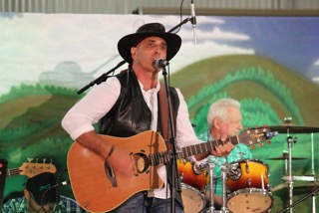
His selection of songs is from Helen Reddy, Roy Orbison, Dean Martin, Chuck Berry, John Denver, Charlie Pride, Billy Ray Cyrus and many other favourites.

BOB HOWSON
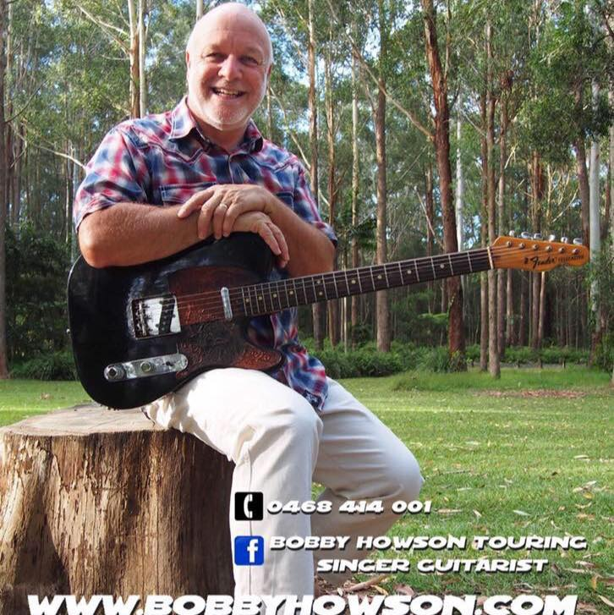
Bob sang during the day at our last rally. We then hired him for our Christmas outing in December. Our members have never had so much fun, we danced and laughed well into the night. Bob puts so much energy into his performances. His songs are ones we can sing along with him and get up and dance also. So much fun did we have that we hired him on the spot for the Tuesday night when our Jacaranda Queen and party are in attendance and for our next Christmas outing. You will love him.
Over the past 40 years Bob has continued to please audiences with his popular style. He has been on three national tours as a support artist to the legendary Brian Young and in ‘The Col Elliot Show’. This talented award-winning singer and guitarist can deliver a beautiful ballad or a raunchy rock hit from the 50’s to the 90’s.

BIG RIVER ROCK AND ROLLERS
These energetic people exhibit this form of dance for you with much gusto. After their performance, you get to join in and try to remember the moves you made as a teenager.
GRAFTON LINE DANCERS
A bunch of enthusiastic ‘older’ people who just love line dancing. They don’t have any costumes for their exhibition, they will show you the steps, then you can join in.
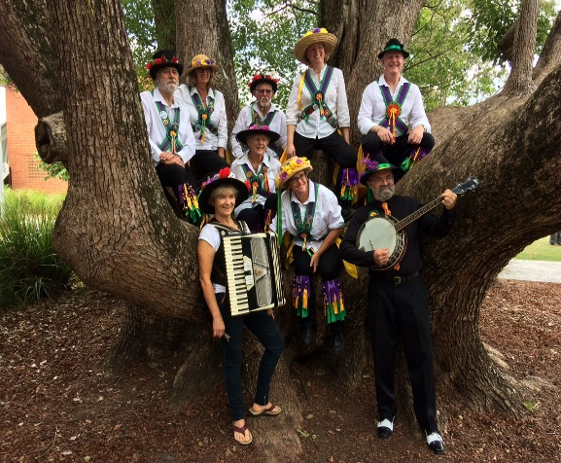
FIDDLESTIX
This group of Morris Dancers performed at our rally last year. Their costumes, bells and sticks are reminiscent of a by gone era of dance in early England. Be blown away by their energy.

BILL KEARNS
Bill had us all in stitches last year as his poetry reflected the life of the grey nomads, RVs and getting old. He is looking forward to telling us about the rock and rollers and line dancers in poetry. Last year he had such an ovation that he had to tell us more of his poetry. He will fill in between the dancing groups so they can have a breather, especially if it is hot – and when isn’t it at Jacaranda time.

CONNOR WILLMORE
Connor has performed with us for 2 years, but a memory loss on his part last year saw him miss our rally in 2018. He has a delightful tenor voice and has been studying music at the Maclean Conservatorium for many years. He commenced his university studies this year in Queensland but assures me he will be available in 2019.
He sings some delightful songs from light opera and musicals, my favourite being ‘If I was a Rich Man’. He is just as much at home with popular music and has a wide repertoire of songs to delight you.
He will fill in during the afternoon as well as after dinner until we have our major raffle draw. The raffle draw is normally held on Saturday night, but the Sunburnt Celts have members who work during the week, so with a change in the program, we can bring you a great Saturday night program of entertainment.
THE SUNBURNT CELTS
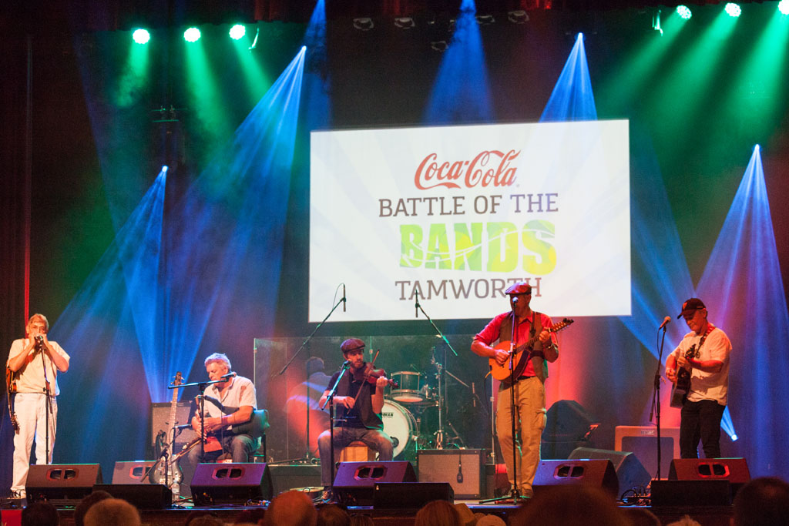
This amazing group of musicians and singers performed at the Camp Oven Festival last year and will be doing so again in August this year. They worked with the Frolhich Brothers at the Camp Oven festival with a most energetic and wonderful program of music, then had bush dance lessons before sending all home for dinner, then came the grand finale, a good old country bush dance.
This band favours festivals, Irish pubs and bush dances, and especially all which have an Irish flavour. They are often booked 12 months in advance
The Sunburnt Celts were formed over 15 years ago with some legends in the folk/Irish music scene among the founding members. They have a style which greatly comprises Australian bush, folk and country with a distinctive lean to the Irish tune scene. Their songs and music cover such artists as John Williamson, Redgum, Lunasa, The Bushwhackers along with some of their own original songs and musical arrangements. Songs such as ‘The Diamantina’ and ‘Botany Bay’ are included in their act.
Their on-stage instrumental variety includes the fiddle, uillion pipes, low D and tin whistles, piano-accordian, harmonica, mandolin, cittern, flute and guitar.
You will not be able to stop your feet from wanting to tap away, or your hands to clap in time with the beat.
Their photo shows them performing at the Tamworth Country Music Festival last year.
FROHLICH BROTHERS
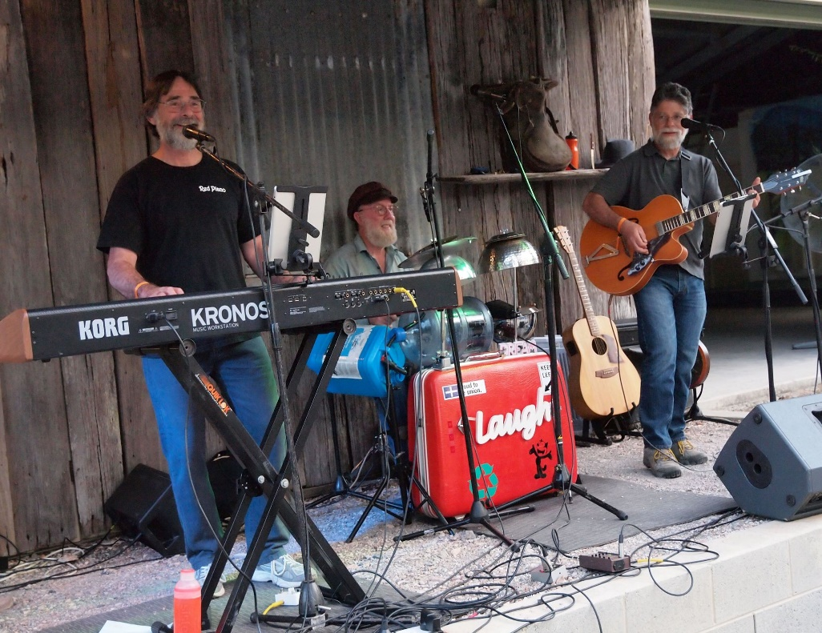
Newcastle – Central Coast musicians, Frohlich Brothers, Martin and Greg Frohlich with percussionist Terry Carlan will play Aussie, Celtic and American retro folk–rock numbers. Frohlich Brothers have toured the North Coast several times over recent years and have featured at the Nymboida Camp Oven Festival. Martin was a well-known Clarence Valley local and played with The Big River Bush Band in the 1980 – 90’s.
The trio features vocals, guitar, mandolin, keyboard, fiddle, recorder and percussion. The trio’s Irish jigs and reels are sure to get your ‘toes-a-tapping’ and brackets will include an eclectic mix of songs and Frohlich Brothers originals.
Frohlich Brothers will also hold a bush dance workshop to introduce bush dance steps to people of all ages in readiness for the evening Celtic Cowboys’ gig in the evening. No prior experience required. The emphasis will be on fun and participation.

